**Day 2: Text and Lists 📝**

Welcome to Day 2! Now that we have the basic structure of an HTML document, it's time to learn how to add and organize the most common type of content: **text**. We'll cover how to create headings, paragraphs, and lists.

**More Than Just Plain Text**

On Day 1, we used <h1> for a heading and <p> for a paragraph. These are two of the most fundamental text elements.

* <h1>: This defines the **most important heading**. Think of it as the main title of a section or the entire page.
* <p>: This defines a **paragraph**. Browsers automatically add a bit of space (a margin) before and after each paragraph.

**There's a whole family of heading elements**: <h1>, <h2>, <h3>, <h4>, <h5>, and <h6>.

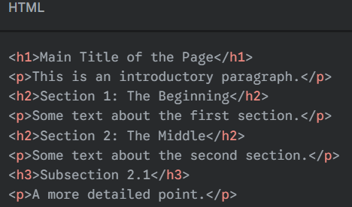The number indicates the level of importance. You should use them in order to create a logical structure. For example, a blog post might have an <h1> for the main title, <h2>s for major sections, and <h3>s for sub-sections.

**Important**: Don't use heading tags just to make text big or bold. Their main purpose is to give your page a **semantic structure**, which is important for search engines and accessibility.

**Emphasizing Text: Bold and Italics**

Sometimes you need to make a word or phrase stand out.

* <strong>: This tag is used to indicate that the text has **strong importance, seriousness, or urgency**. Browsers will typically display this as **bold** text.
* <em>: This tag is used to **emphasize** text. Browsers will typically display this as *italicized* text.

**Example**:

<p><strong>Warning:</strong> Do not touch the hot surface. It is <em>very</em> important to be careful.</p>

**Organizing Information: Lists**

Lists are perfect for grouping related items, like ingredients in a recipe or steps in a set of instructions. There are two main types of lists in HTML.

**1. Unordered Lists <ul>**

Use an unordered list when the **order of the items does not matter**. This is your standard bulleted list.

* The entire list is wrapped in <ul> (unordered list) tags.
* Each item in the list is wrapped in <li> (list item) tags.

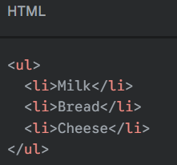**Example**:

This will be displayed as:

* Milk
* Bread
* Cheese

**2. Ordered Lists <ol>**

Use an ordered list when the **sequence of the items is important**, like in a recipe or a top-10 list. This creates a numbered list.

* The entire list is wrapped in <ol> (ordered list) tags.
* Each item is still wrapped in <li> tags. The browser will automatically handle the numbering for you.

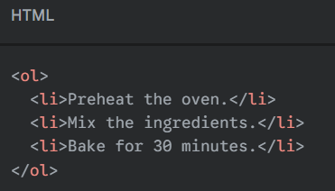**Example**:

This will be displayed as:

1. Preheat the oven.
2. Mix the ingredients.
3. Bake for 30 minutes.